Downton Abbey
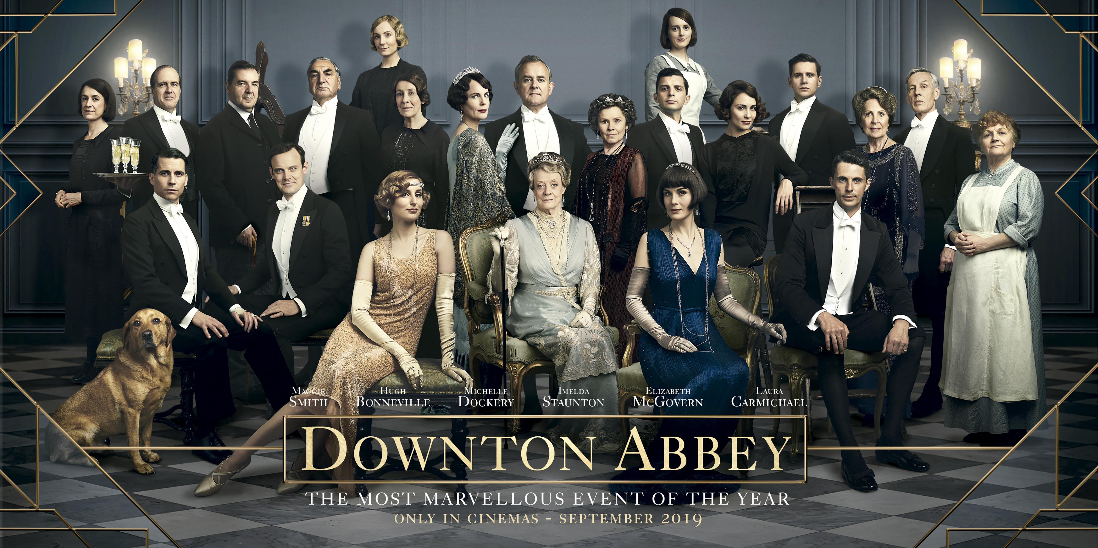
Downton Abbey was originally a British historical period drama television series that aired from 2010 to 2015. It was set as a fiction based in a historical landscape between 1912 and 1926, in the post-Edwardian era where historical events had a real influence on the British social hierarchy. The movie takes place after the end of the last season. Fans will definitely recognise the famous characters.
Vocabulary: British aristocracy, mansion lifestyle, modern versus old-fashioned
Phonology: final “s”, the various sounds for “i”, syllable stress
Grammar: preterite, passive form
Cultural element: British social classes and history
Describe the picture :
________________________________________________________________________________________________________________________________________________________________________________________________________________________________________________________________________________________________________________________________________________________________________________________________________________________________________________

1
Downton Abbey Activities
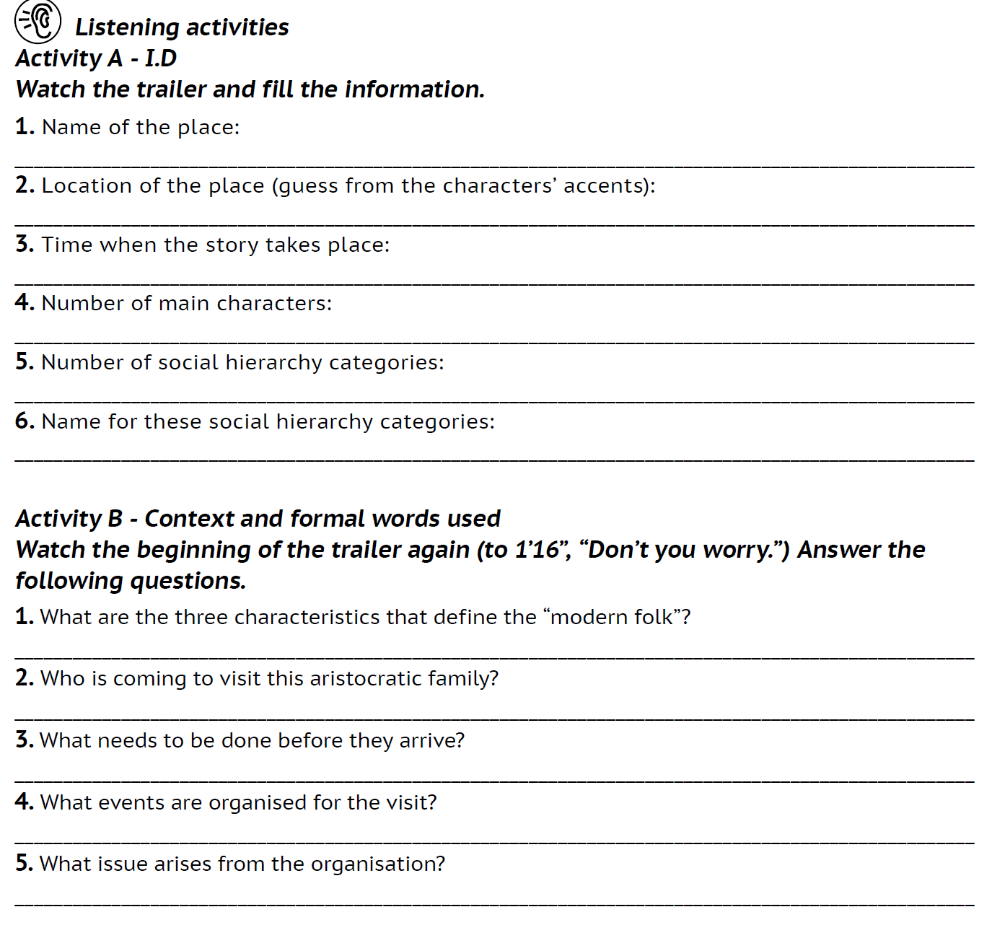

2
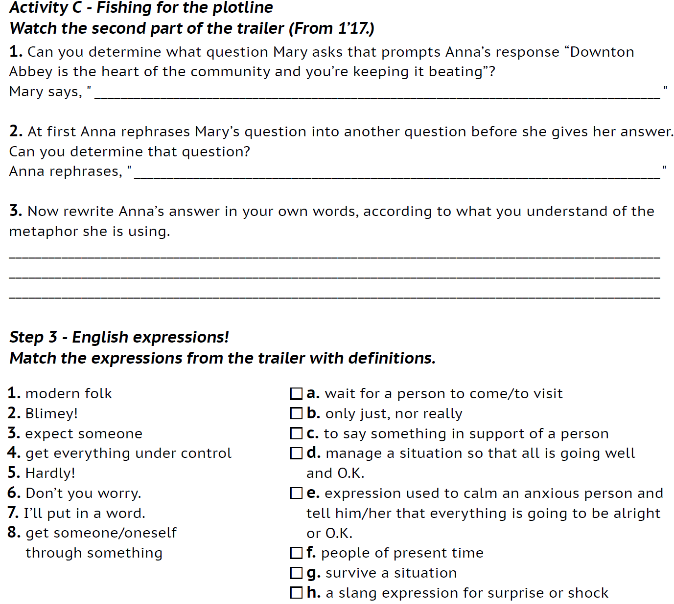

3
General Listening Grid
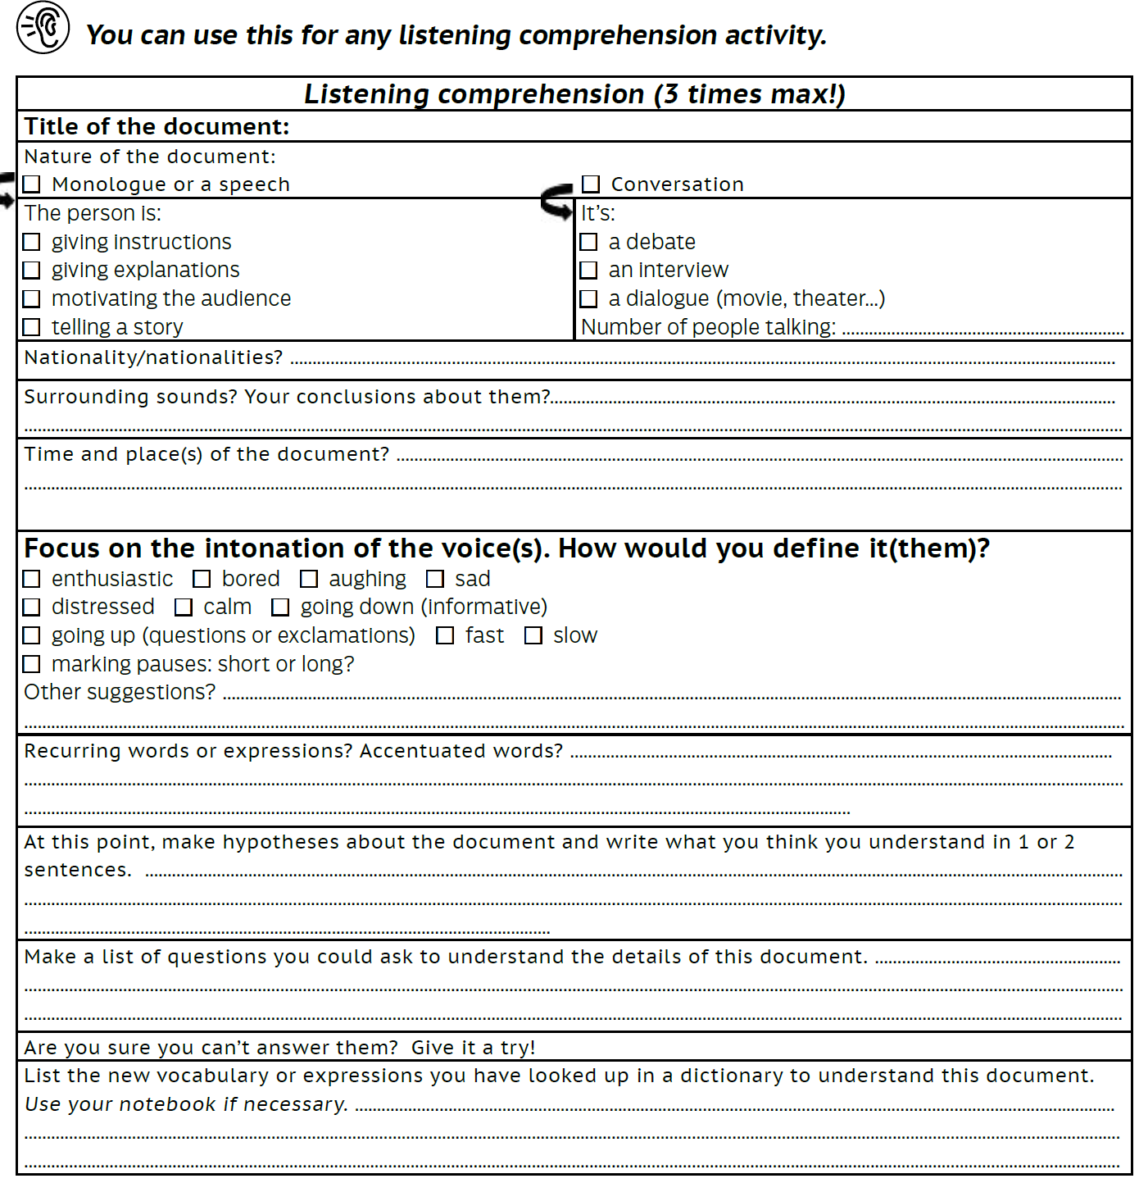
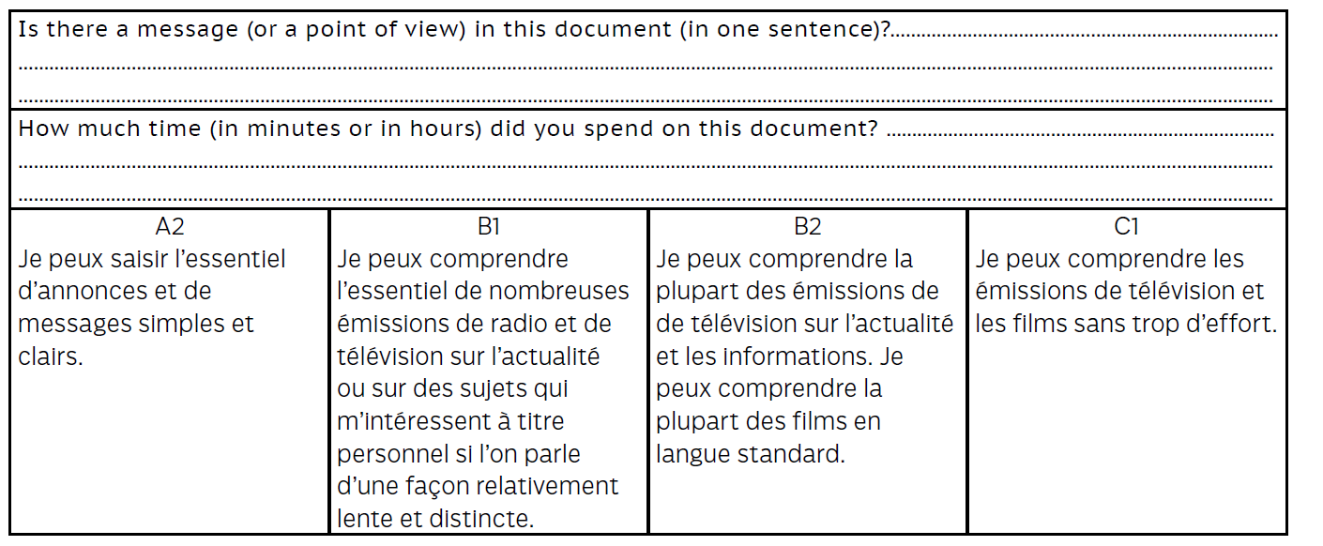

4

