LISTEN TO THE PODCAST ABOUT THE FIRST FLEETAND TRY TO GET AS MUCH INFORMATION AS YOU CAN:

- People on board:

- Reason for the journey:

- Draw the journey from England to Australia and write the names of the different stops:
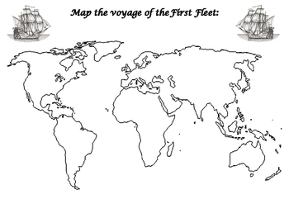

- What do these dates and numbers correspond to?
13th May 1787: ………………………………………………………………………………………………………..……….
11: ……………………………………………………………………………………………………….……………………………
1,000: …………………………………………………………………………………………….…………………………………
252 days: ………………………………………………………………………………………….…………………………………
48 : ……………………………………………………………………………………………………………………………………..
1,400: …………………………………………………………………………………………….………………………………….
January 26th 1788: ……………………………………………………………………………………………………………….

